Pearson’s correlation analysis

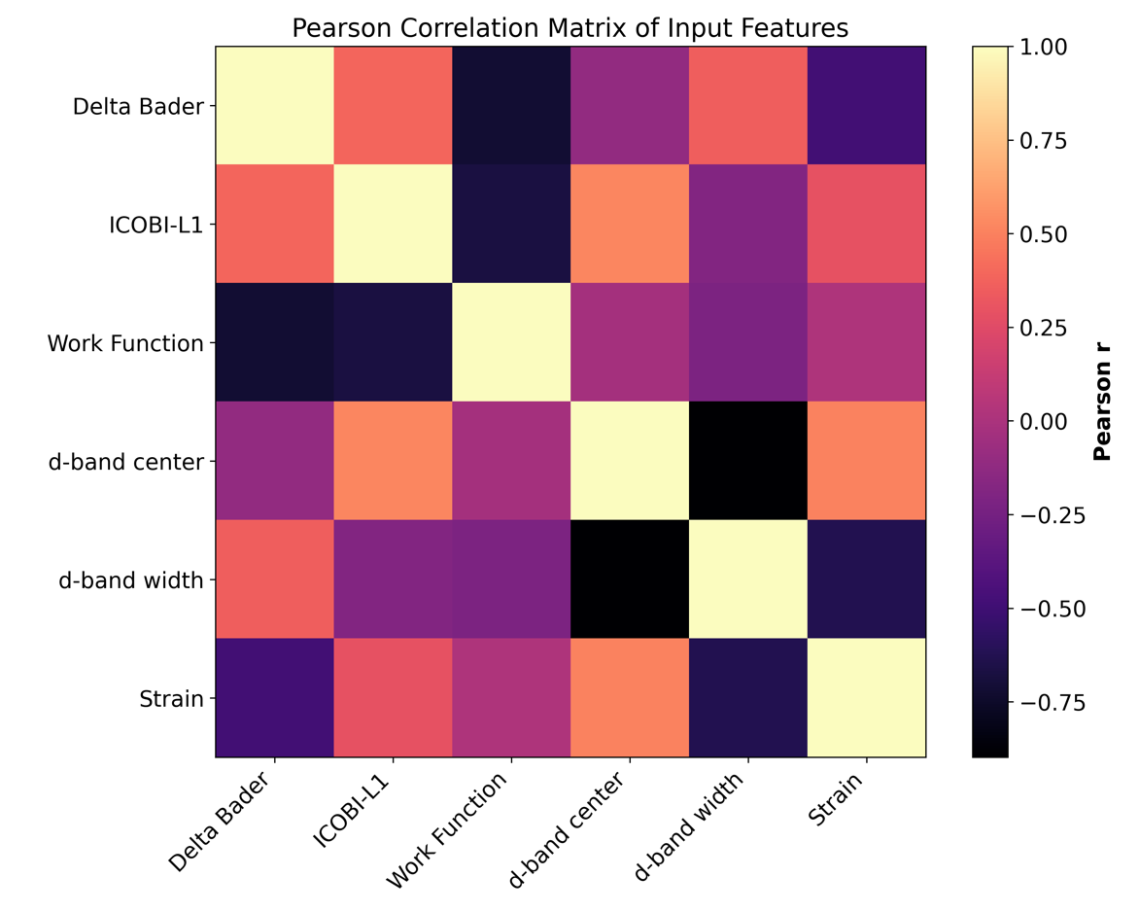
Parity analysis
GPR 6
"Delta Bader", "ICOBI-L1", "Work Function", "d-band center", "d-band width", "Strain"
In-sample: MAE=0.043574, RMSE=0.003014, R2=0.972856
LOOCV: MAE=0.161142, RMSE=0.042907, R2=0.613570
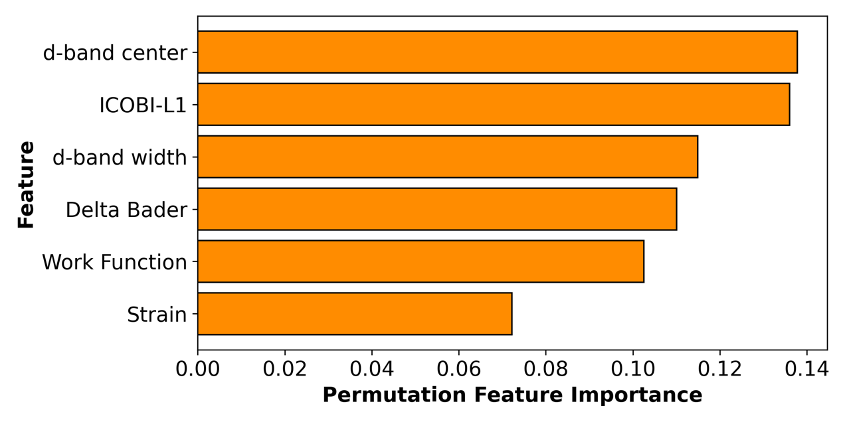

In-sample plot LOOCV plot
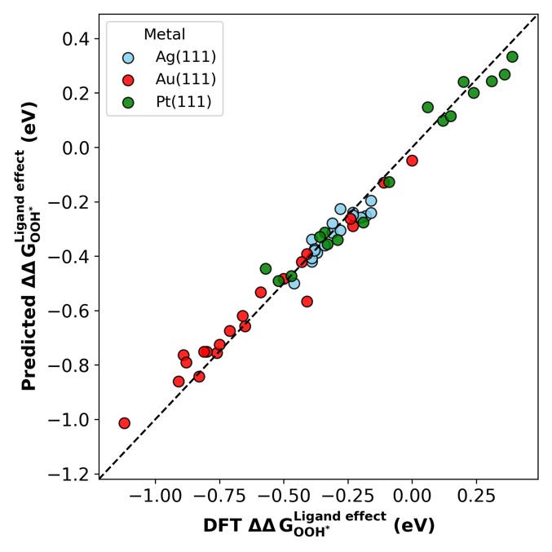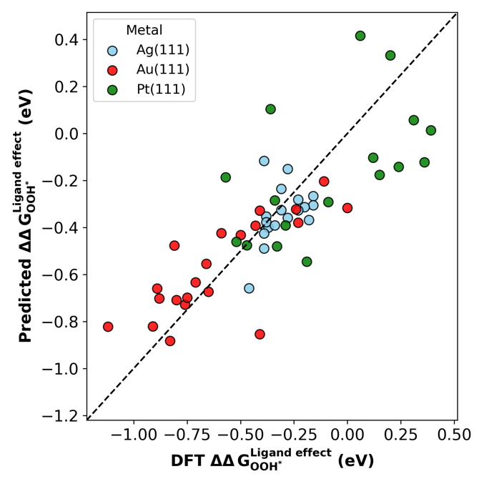

GPR 5
"Delta Bader", "ICOBI-L1", "Work Function", "d-band center", "Strain"
In-sample: MAE=0.042583, RMSE=0.002835, R2=0.974467
LOOCV: MAE=0.163822, RMSE=0.043993, R2=0.603786

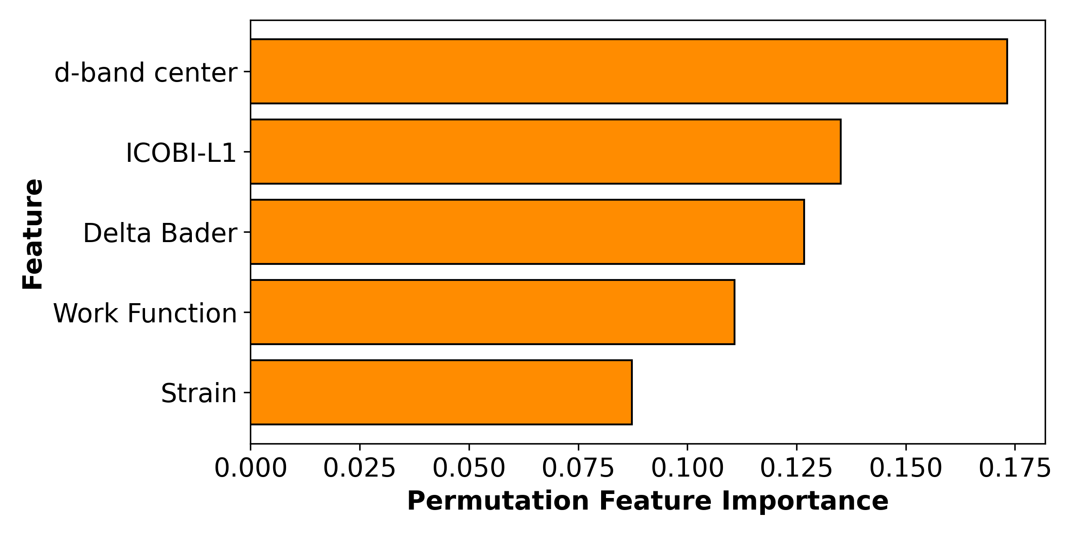
In-sample plot LOOCV plot
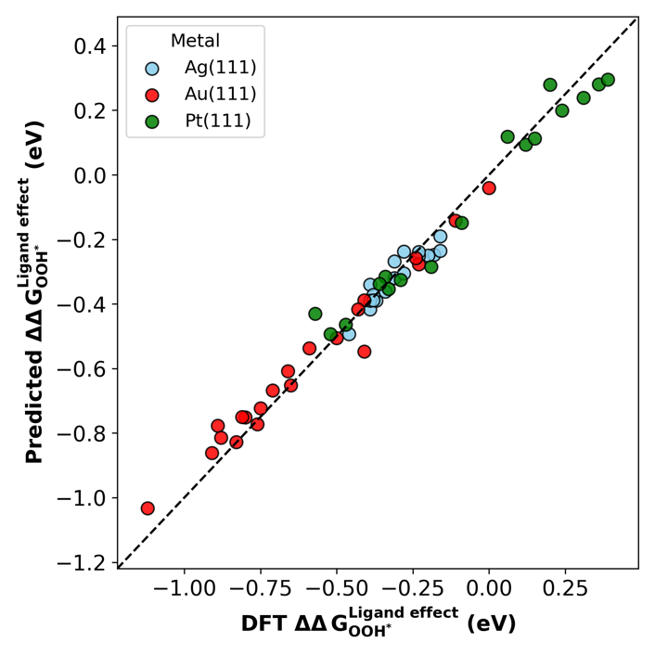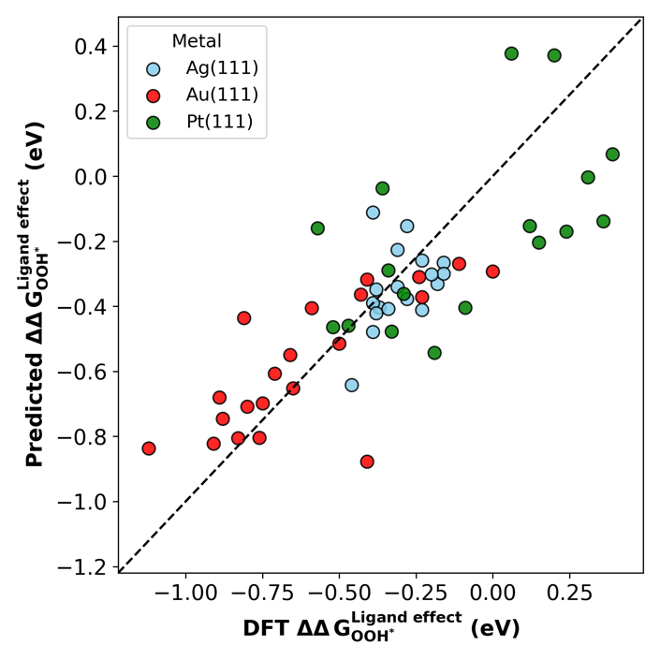

GPR 4 - Strain
"Delta Bader", "ICOBI-L1", "d-band center", "Strain"
In-sample: MAE=0.042719, RMSE=0.002901, R2=0.973871
LOOCV: MAE=0.151455, RMSE=0.039767, R2=0.641846

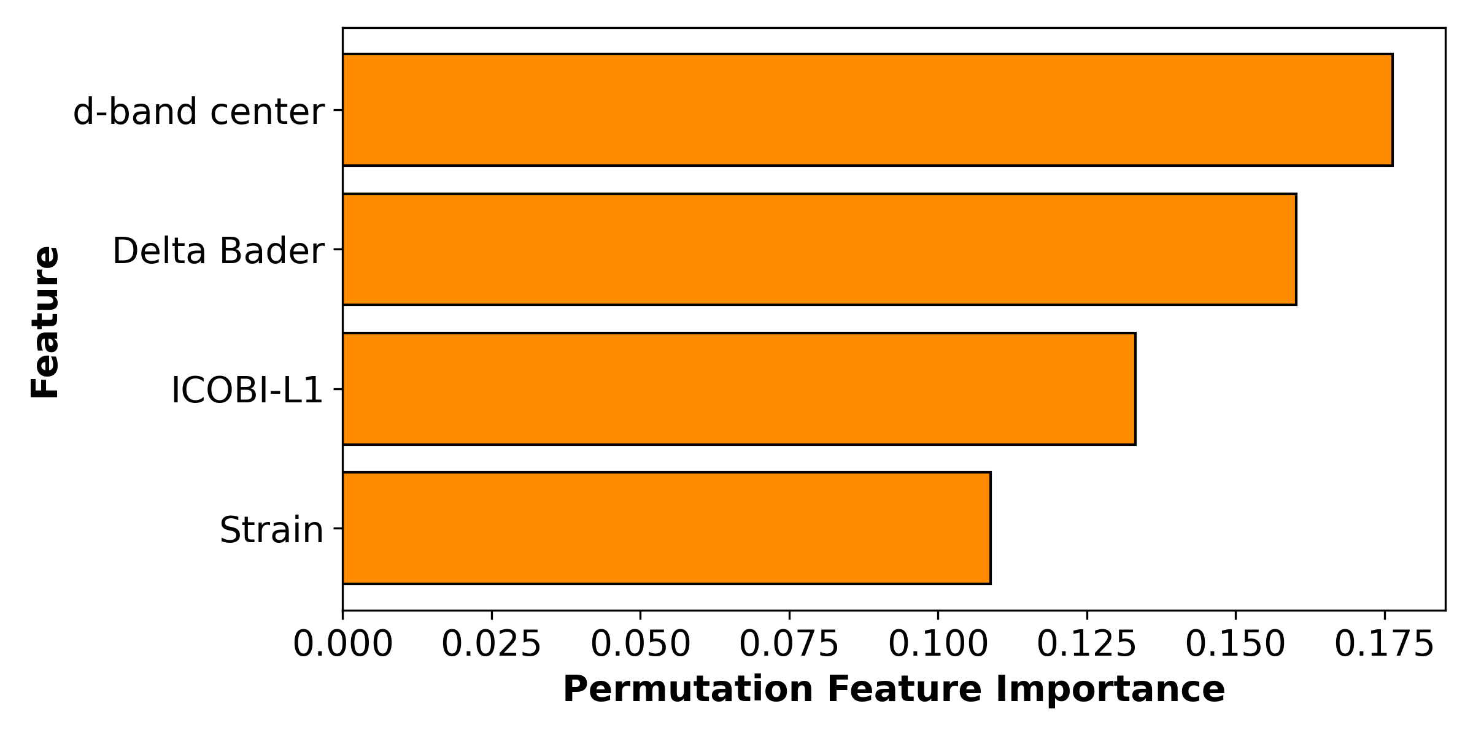

In-sample plot LOOCV plot
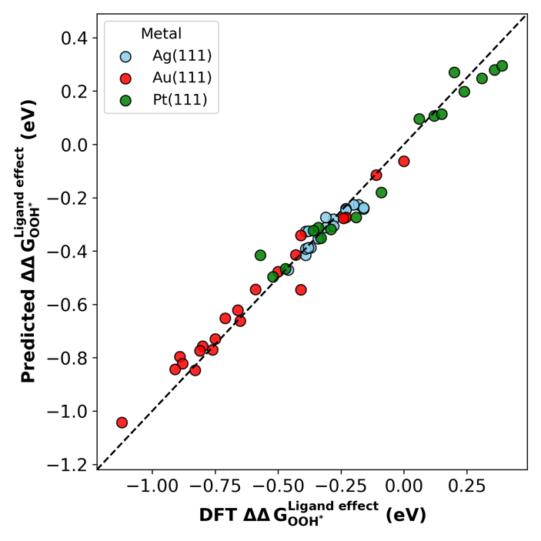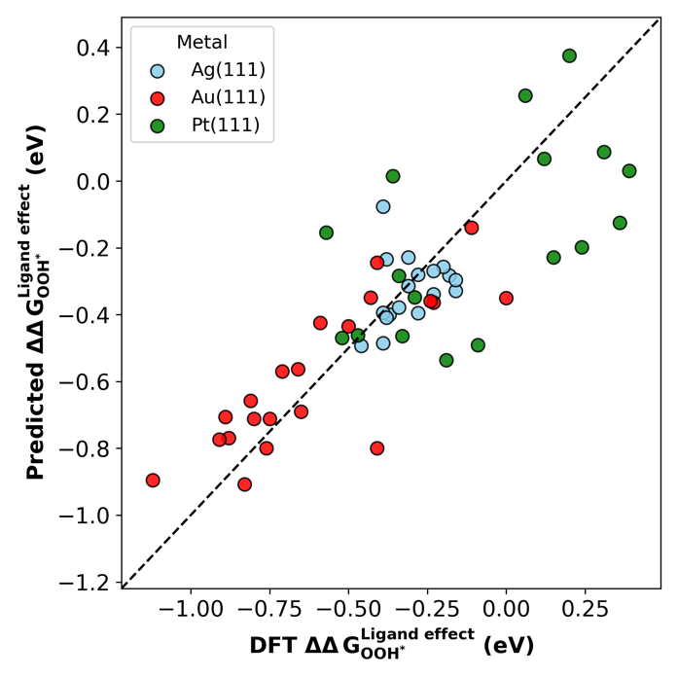
GPR 4 – Work function
"Delta Bader", "ICOBI-L1", "Work Function", "d-band center"
In-sample: MAE=0.039547, RMSE=0.002916, R2=0.973741
LOOCV: MAE=0.141829, RMSE=0.039785, R2=0.641681
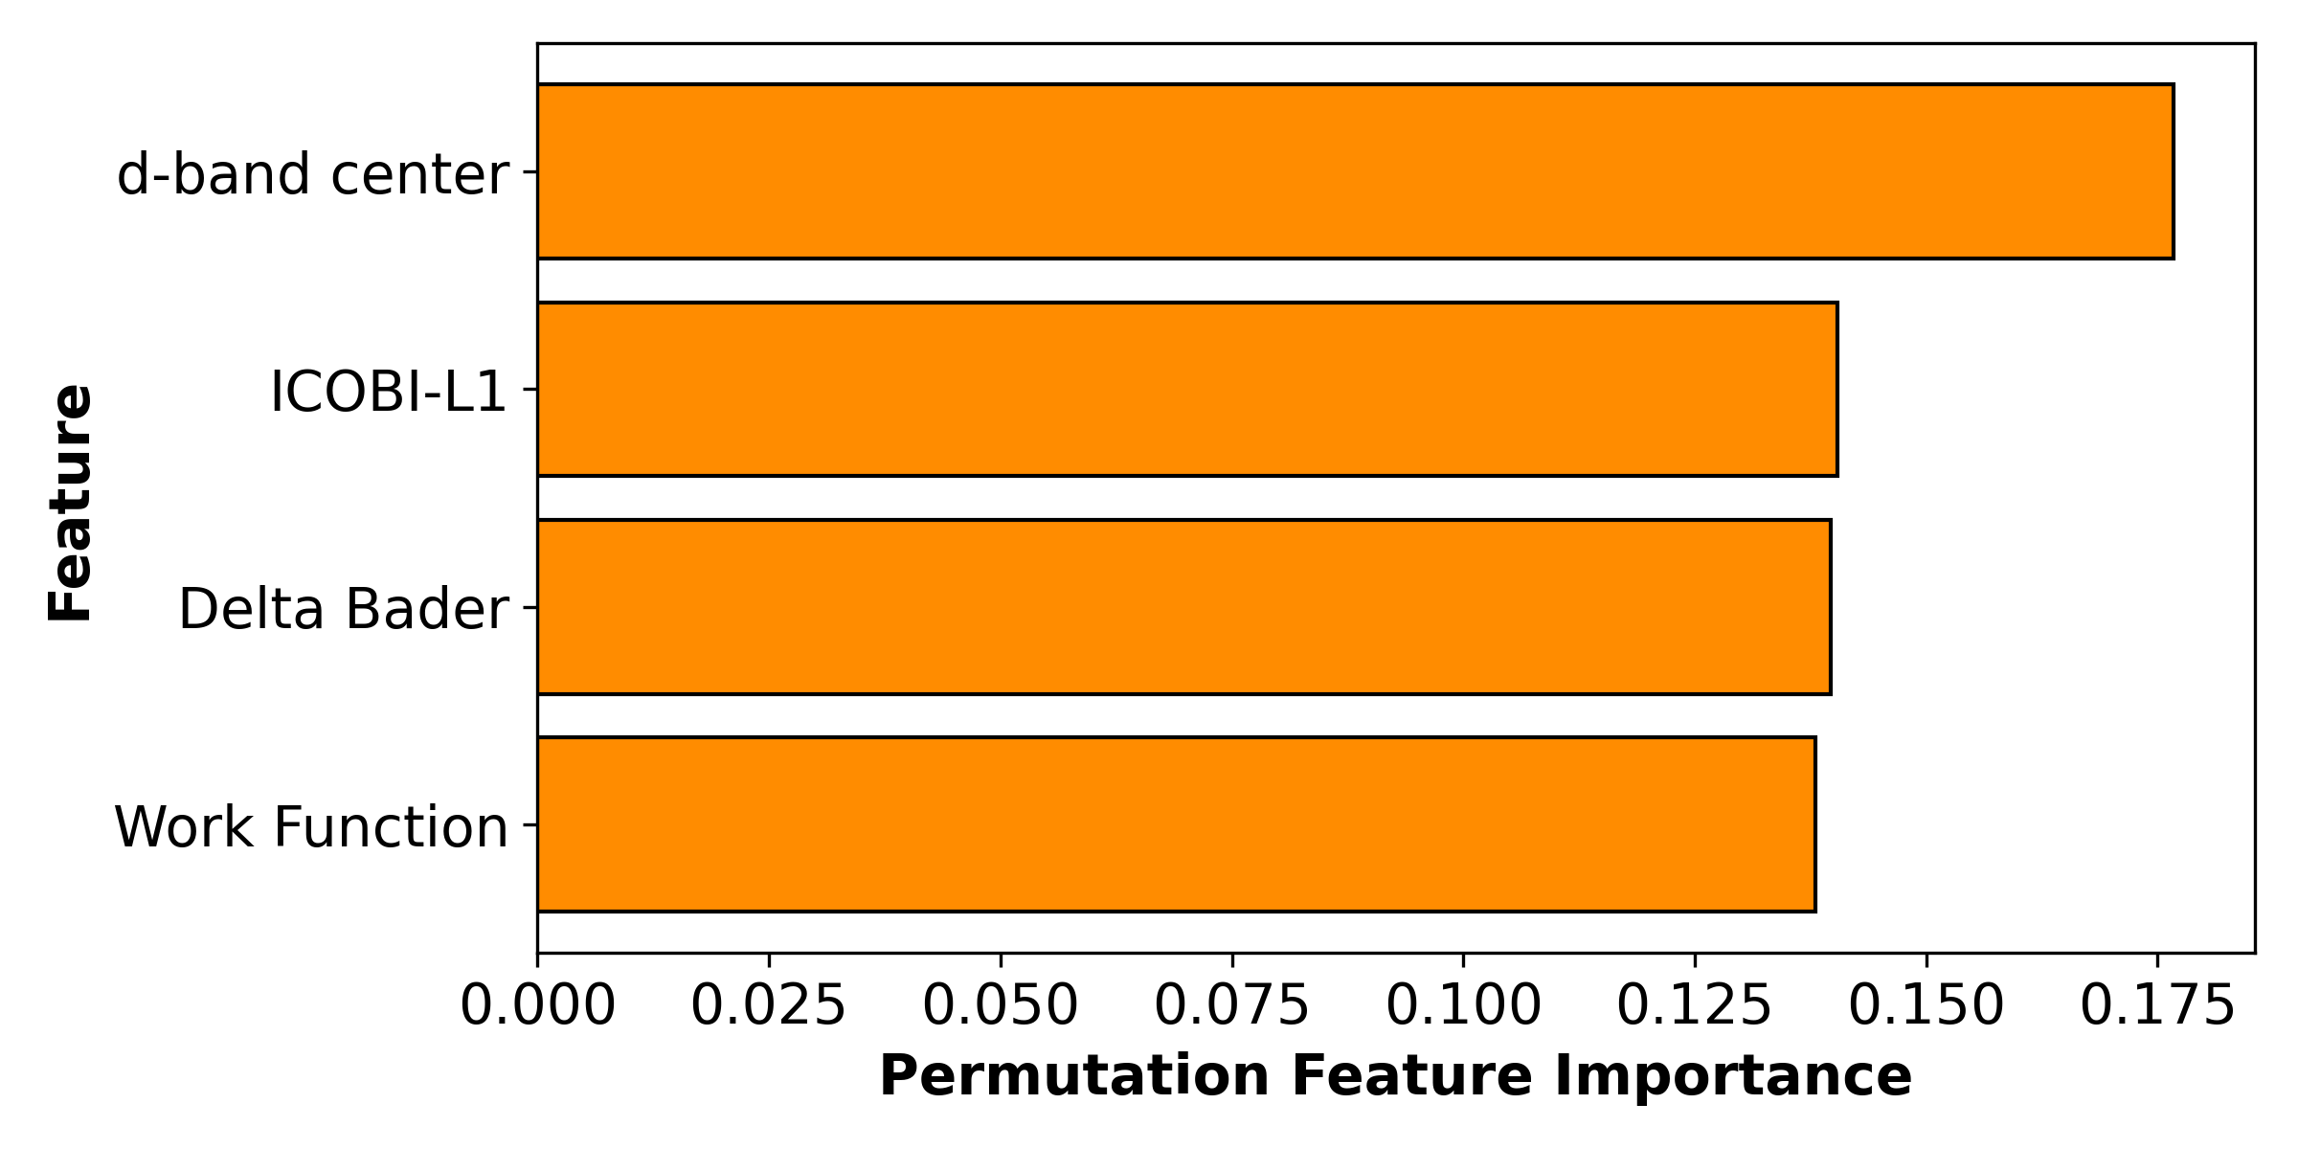

In-sample plot LOOCV plot
